JCKC Accounting and Bookkeeping Services App
User Guide - Release 1.0.0
Developed by: Wakai One

1. About the App
The JCKC Accounting and Bookkeeping Services App is a desktop application that keeps your client records, reports, and supporting information in one place. It reduces repeated typing, manual copying of templates, and switching between separate programs.
Main features:
- Taxpayer Information Management
- SLSP Generation
- BIR Confirmation Email Integration
- Built-in Sum Calculator
- Supplier Management

2. System Requirements
- Windows 10 or Windows 11 (64-bit)
- No separate Java installation is needed. The app includes everything it needs.
- An internet connection is required for the BIR Confirmation Email feature.3. Installation
- Download the installer file, JCKC_App-1.0.0.msi.
- Double-click the file to start the installation.
- If Windows shows "Windows protected your PC", click More info, then click Run anyway. This message appears because the installer is not digitally signed.
- Wait for the installation to finish.
- Open the app from the Desktop shortcut or from the Start Menu.

4. Logging In
- Open the app.
- Enter your password on the login screen.
- Click [Submit].
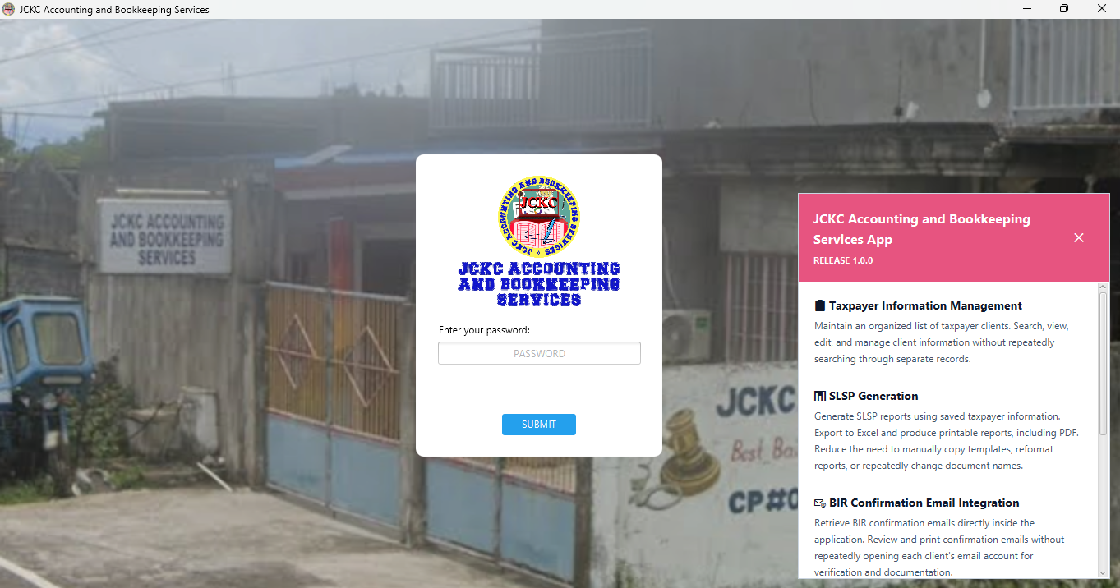

5. Taxpayer Information Management
Keep an organized list of taxpayer clients. You can search, view, edit, and manage client information without searching through separate records.
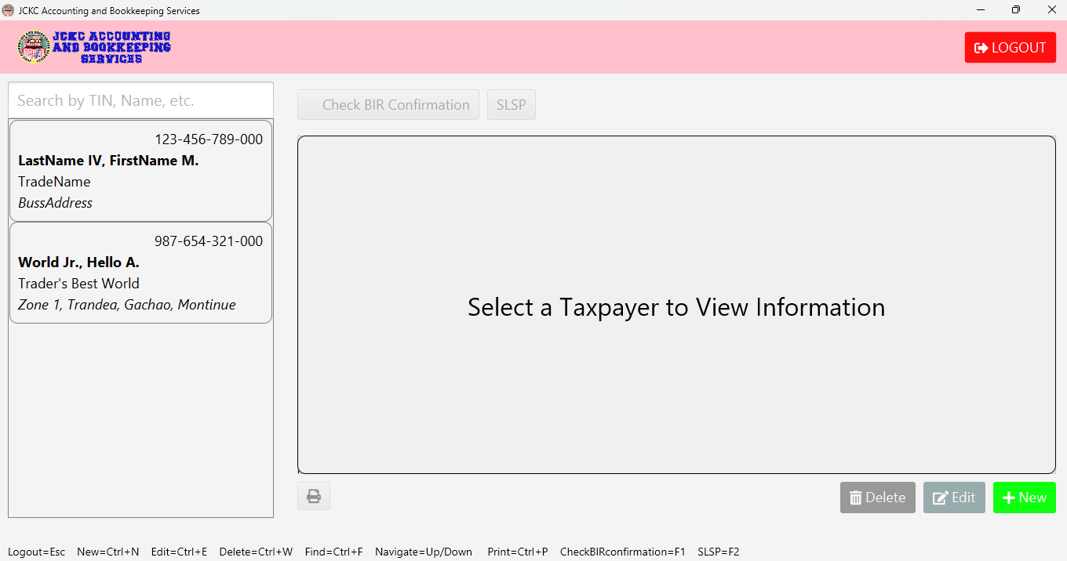

5.1 Searching for a Taxpayer
- Open the taxpayer list.
- Type a name, TIN, or trade name in the search box.
- Click the matching record to open it.

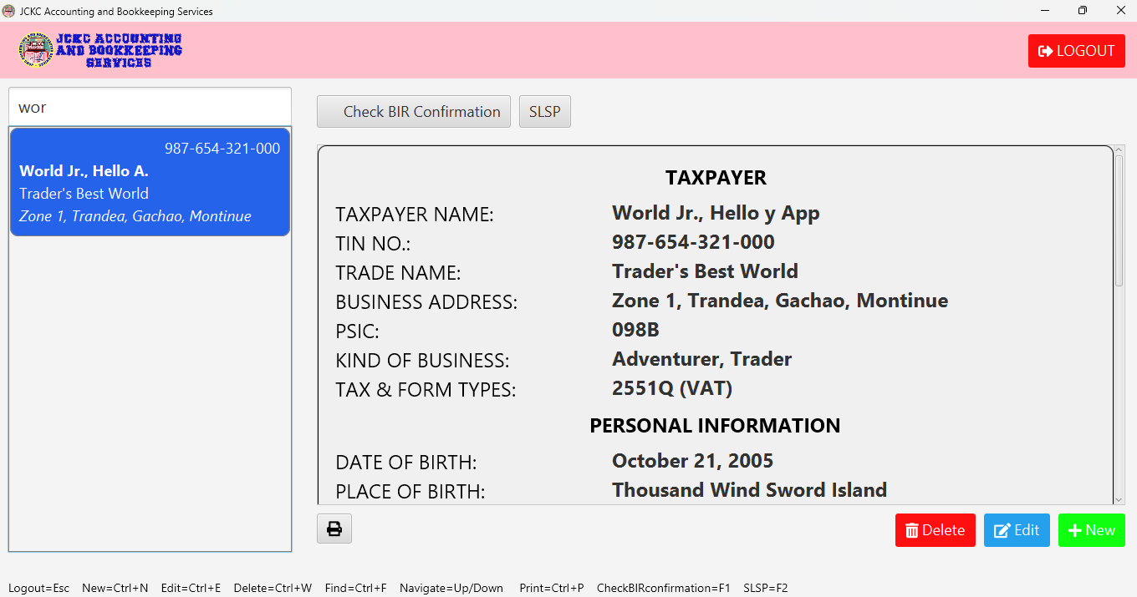5.2 Adding a New Taxpayer
- Click [New].
- Fill in the taxpayer's details: name, TIN, trade name, business address, kind of business, PSIC, form types, and VAT status.
- Fill in the personal information and email account details if needed.
- Click [CREATE].

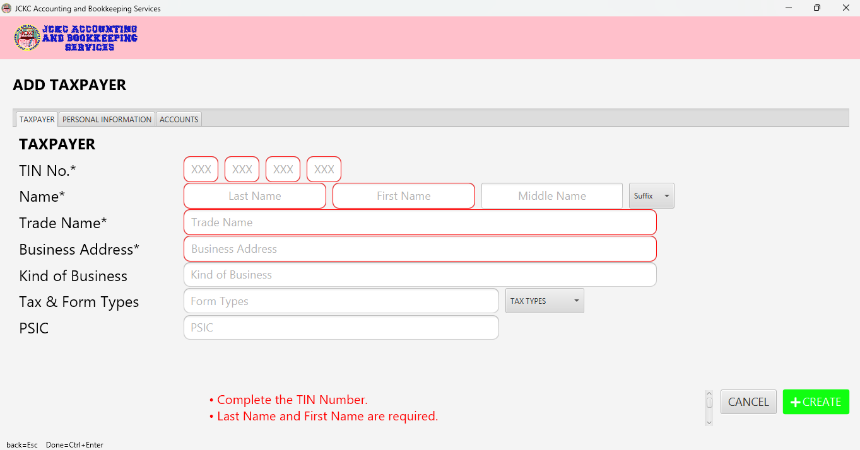5.3 Viewing and Editing a Taxpayer
- Select a taxpayer from the list.
- Click [Edit].
- Change the details you need.
- Click [UPDATE].

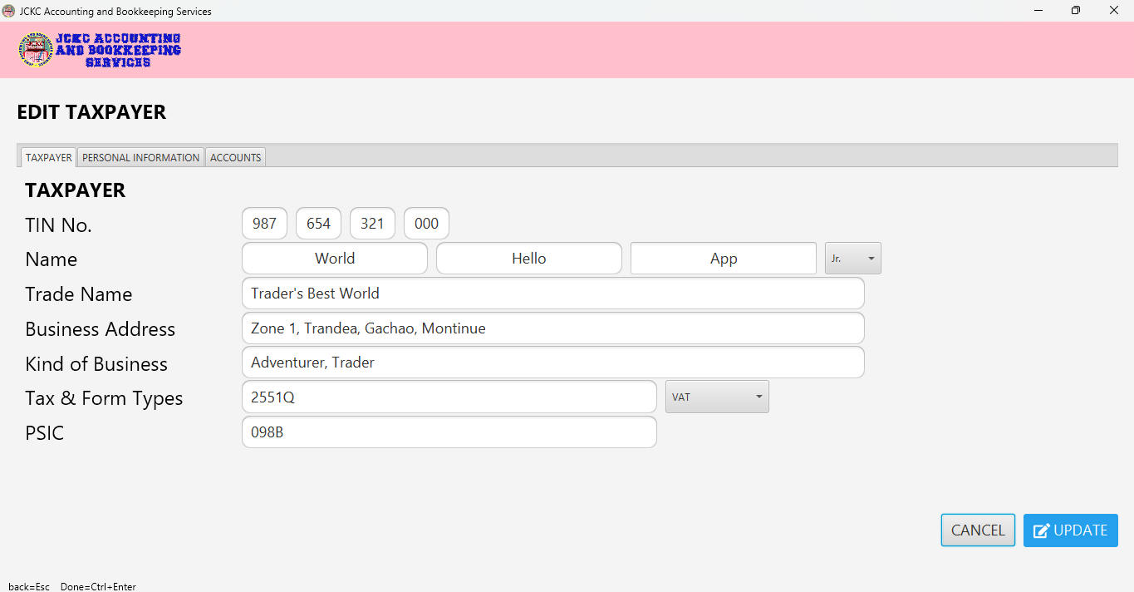5.4 Deleting a Taxpayer
- Select the taxpayer in the list.
- Click [Delete].
- Confirm the deletion by typing “DELETE”.
Warning: Deleting a taxpayer also removes the records linked to that taxpayer, such as personal information, accounts, suppliers, SLSP records, and saved emails. This cannot be undone. Make a backup first (see Section 10).

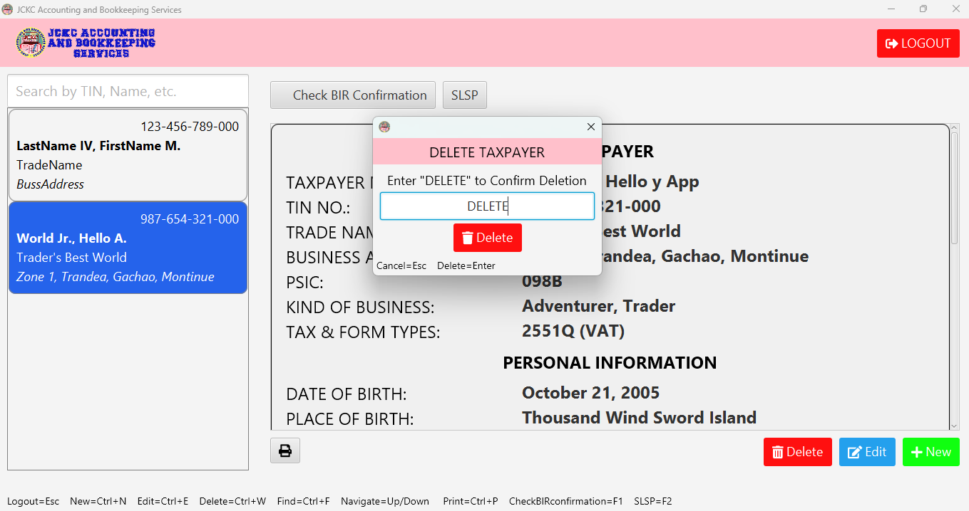6. SLSP Generation
Generate SLSP reports using the saved taxpayer information. You can export to Excel and produce printable reports, including PDF. This removes the need to copy templates, reformat reports, or rename documents by hand.

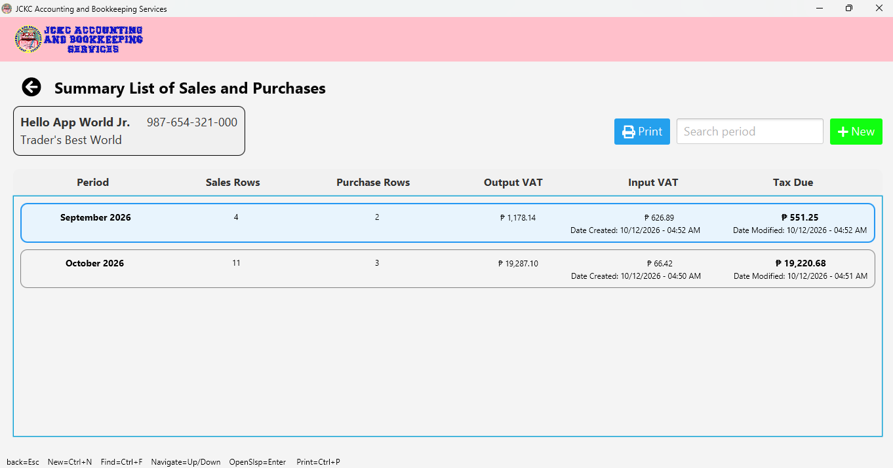6.1 Creating an SLSP Report
- Select the taxpayer.
- Open the SLSP screen.
- Choose the period (month, quarter, or year).
- Enter or review the Sales records.
- Enter or review the Purchase records.
- Check that the totals are correct.
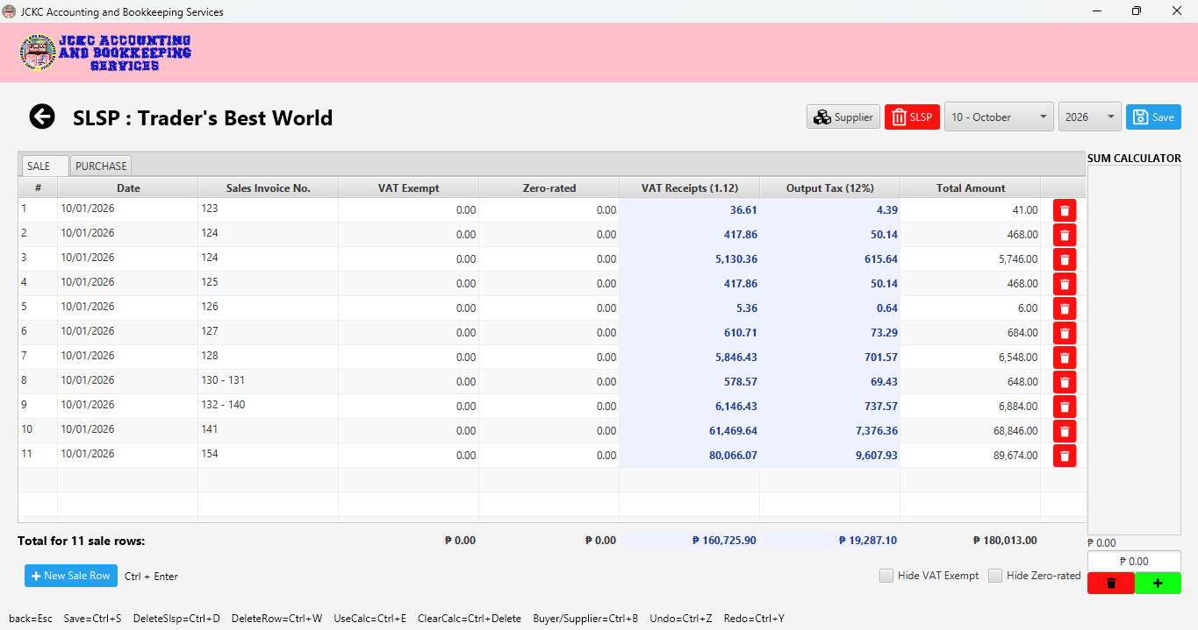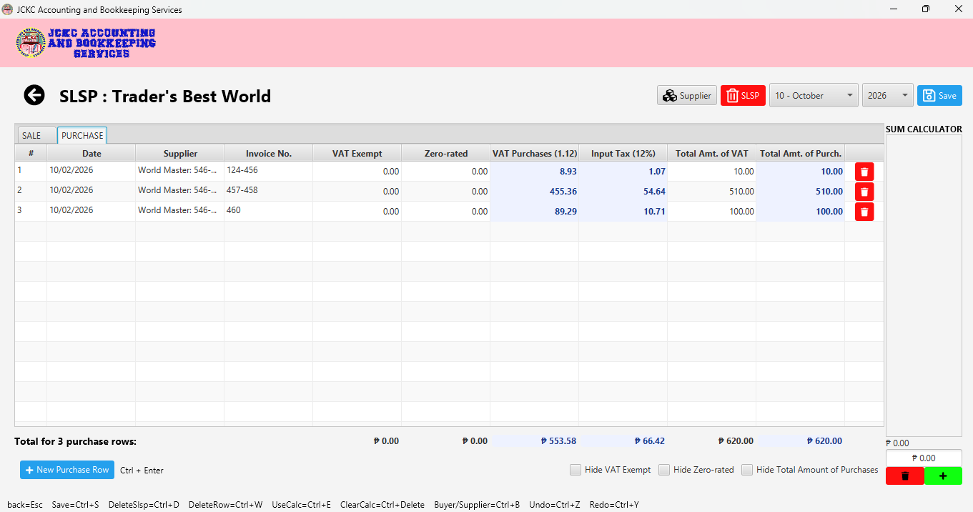

6.2 Exporting to Excel or Printing
- From the Summary List of Sales and Purchases.
- Click [Print].
- You can manage the Print range from Whole year or By quarter.
- You can include Sales or Purchases.
- It can show which are missing on the RED TEXTS.
- Click [Export to Excel] to manually edit data and go traditional.
- Click [Print] to get a copy and send on taxpayers via PDF.

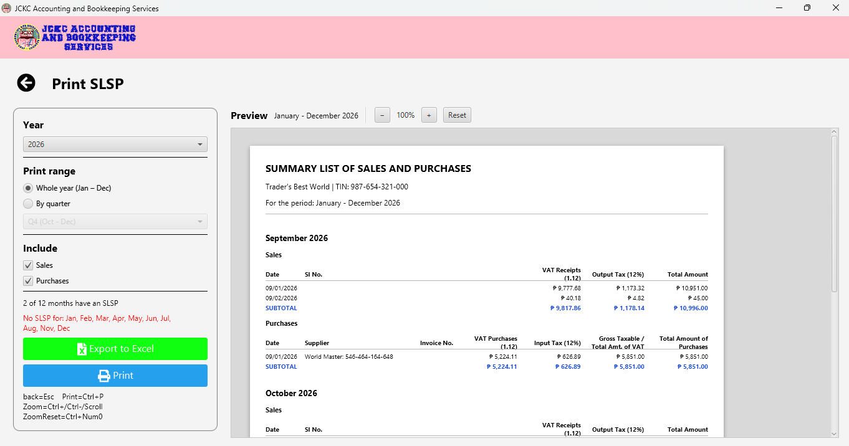

6.3 Keyboard Shortcuts
Shortcut | Action
Ctrl + D | Deleting SLSP (Applies on SLSP Manager).
Delete | Clears lists in Sum Calculator (Applies on SLSP Manager).
Ctrl + S | It’s for Saving (Applies on SLSP Manager).
Ctrl + Z | It’s for Undo (Applies on SLSP Manager).
Ctrl + Y | It’s for Redo (Applies on SLSP Manager).
Ctrl + Enter | Saving Data and Display.
Enter | Can also create rows in SLSP Manager, but it actually selects rows on lists like Taxpayer, Messages, SLSP, It can also switch Save/Edit in Manage App Password.
Ctrl + N | Direct to Creation Screens such as SLSP Manager or Add Taxpayer.
Ctrl + W | Removing Data and Display.
Ctrl + F | Would Direct to Search Bars (Taxpayer, SLSP, BIR Confirmations).
Ctrl + E | Edit Data like Taxpayer and App Password but can also help direct cursor to sum calculator in SLSP… Manager.
Up/Down | Navigation for any lists or rows.
Ctrl + B | It could mean Buyer or Supplier in SLSP Manager or Browser in Manage App Password.
Esc | Back
Ctrl + P | Printing

7. BIR Confirmation Email Integration
Retrieve BIR confirmation emails directly inside the application. Review and print them without opening each client's email account for verification and documentation.

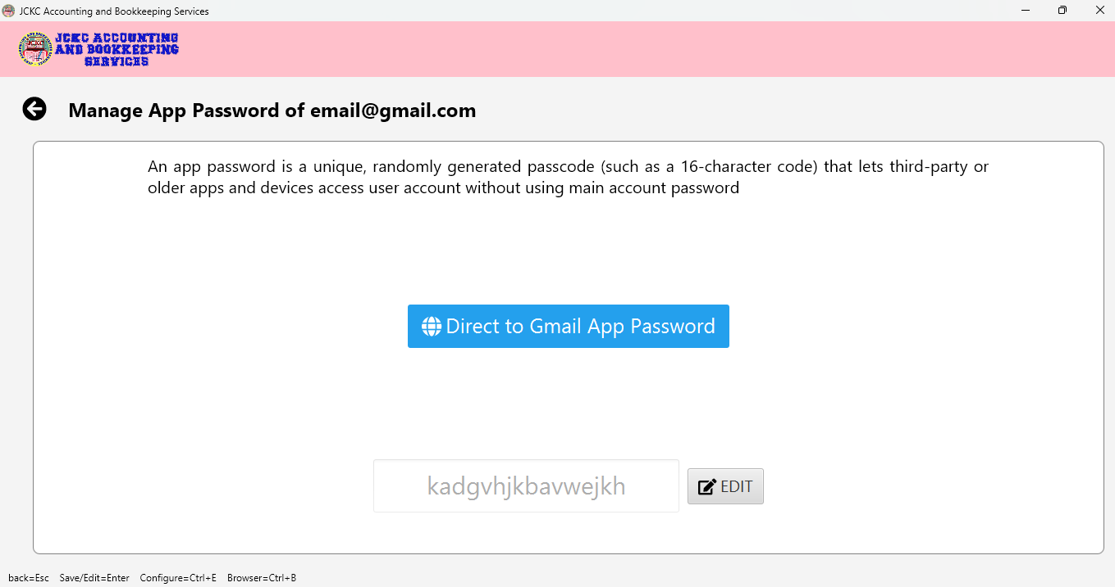7.1 Before You Start
- The taxpayer's email account (Gmail or Yahoo) must be saved in their record.
- The email account may need an app password. Enter it in: [Check BIR Confirmation] from Taxpayer Lists (Home).
- When you had put the app password going back [<] would direct you to BIR TAX CONFIRMATION.
- Your computer must be connected to the internet.

7.2 Viewing Confirmation Emails
- Select the taxpayer from Taxpayer Lists (Home).
- Click [Check BIR Confirmation] to proceed to BIR TAX CONFIRMATION only if you have app password.
- Automatically will decide whether the email account to check is [Gmail / Yahoo] but Gmail is in priority (Example: You have both email but Gmail would be checked instead of Yahoo).
- Click [Refresh], would help receive new message although it will check on real-time.
- Click [Clear Cache] isn’t necessary but do it to clean some space. However, you will be downloading the messages again.
- Click a mail in the list to read from ebirforms-noreply@bir.gov.ph or esubmission@bir.gov.ph.
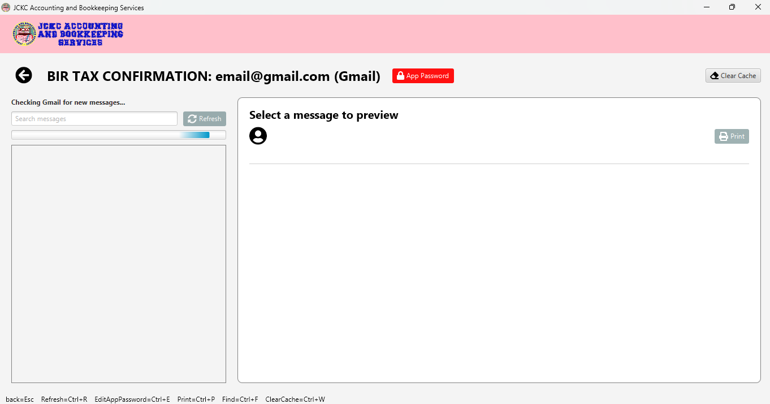
The app saves a copy of fetched emails on your computer, so older emails open quickly. Only new emails are downloaded on the next refresh.

7.3 Printing an Email
- Open a message.
- Click [Print].
- Choose a printer or Save as PDF.

8. Built-in Sum Calculator
Do quick calculations inside the app without opening another calculator.
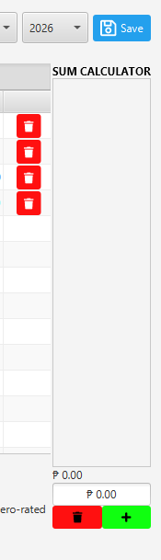
How to use it:
- The Sum Calculator is located in SLSP Manager.
- Enter the numbers and submit by [+] or Enter.
- Read the total shown and lists.
- Click the number from the lists to remove some rows.
- Click [Trash-icon] to clear and start a new computation.

9. Supplier Management
Keep an organized supplier list and reuse saved supplier information, including TIN details. This reduces repeated typing and the need to look up the same supplier again.

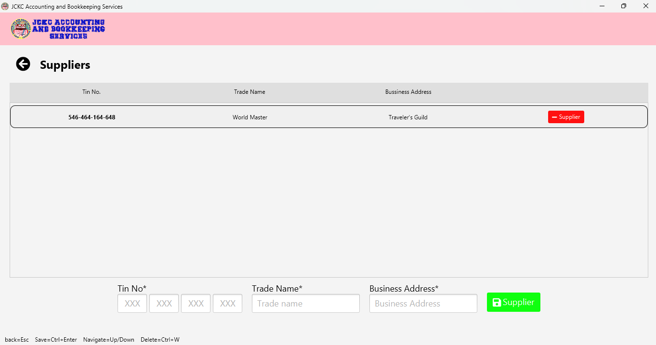9.1 Adding a Supplier
- Open the Suppliers screen from SLSP Manager.
- Enter the supplier's name, TIN, and address.
- Click [Supplier].

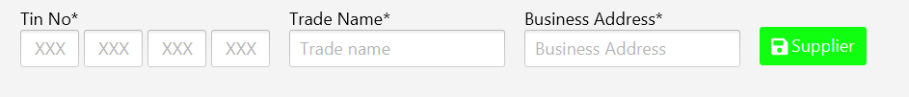9.2 Using a Saved Supplier
- When entering a purchase, choose the supplier from the list.
- The saved details are filled in for you.

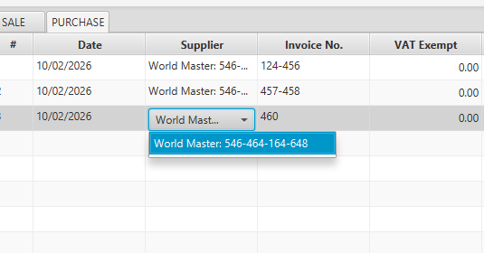

9.3 Editing or Removing a Supplier
- Select the supplier in the list.
- Click [Supplier].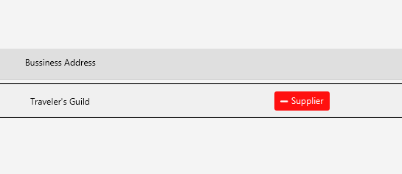

10. Backing Up and Restoring Your Data
Your data is stored in one file on your computer:
C:\Users\[YourName]\.jckc\jckc-app.db
Backup (do this regularly):
- Close the app.
- Open File Explorer and go to C:\Users\[YourName]\.jckc.
- If you cannot see the folder, type the path into the address bar.
- Copy jckc-app.db to a flash drive or cloud folder.
- Add the date to the copy's name, for example jckc-app-2026-10-12.db.
Restore:
- Close the app.
- Copy your backup file into C:\Users\[YourName]\.jckc.
- Rename it to jckc-app.db, replacing the existing file.
- Open the app.
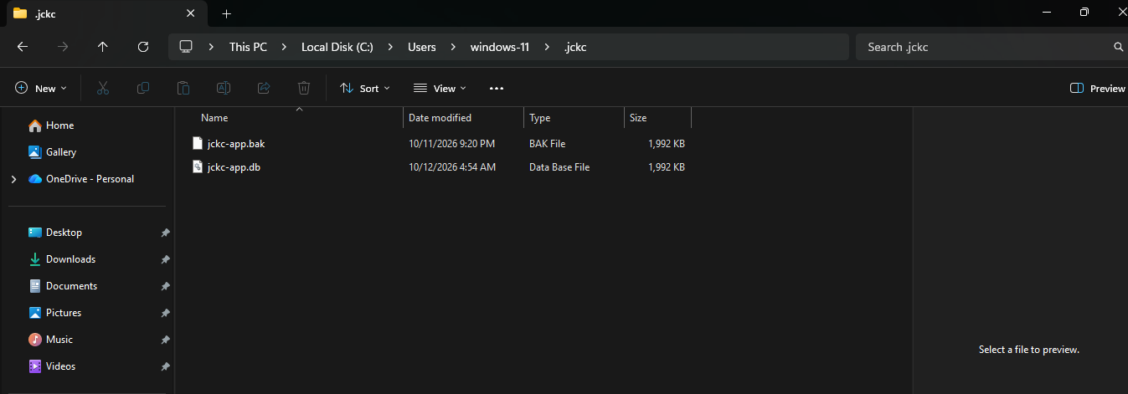Back up your data before every update.

12. Uninstalling
- Open Settings, then Apps, then Installed apps.
- Find JCKC_App and choose Uninstall.
- Your data file in the .jckc folder is not deleted. Delete it yourself only if you no longer need the data.

13. Troubleshooting
Problem | What to try
The installer shows "Windows protected your PC" | Click More info, then Run anyway.
The app does not open | Restart the computer and try again. If it still fails, contact support.
Data looks empty after install | Check that jckc-app.db exists in C:\Users\[YourName]\.jckc. Restore from a backup if needed.
BIR emails do not load | Check your internet connection and the email account details saved for the taxpayer.
Excel or PDF export fails | Make sure the file is not already open in another program, then try again.

14. Support and Release Information
- App: JCKC Accounting and Bookkeeping Services App
- Release: 1.0.0
- Developed by: Wakai One
- Contact: jovenkclaudio24@gmail.com / +639912306158 / Joven K Claudio
More improvements and bug fixes will come in future releases.

